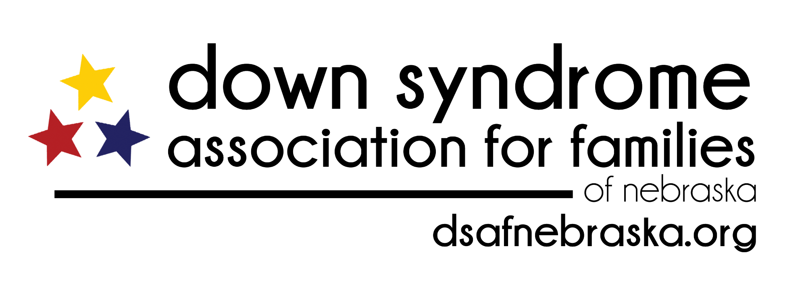
Release of Information AUTHORIZATION FORM

To: Down Syndrome Association for Families of Nebraska
PO Box 57362 Lincoln ,NE 68505
402-601-2498
medicaloutreach@dsafnebraska.org

I, ____________________________ hereby authorize _________________________
and it’s affiliates, its employees and agents to release to the Down Syndrome Association for Families of Nebraska (DSAF) my personal contact information which identifies my name, email address, hospital room number, and phone number for the purpose of helping me connect to community resources and supports related to Down syndrome. This authorization is valid from the date of my signature below and shall expire in 6 months from the date of signature.

I understand that I have a right to revoke this authorization by providing written notice to _________________________________. I also understand that I have a right to have a copy of this authorization. I further understand that this authorization is voluntary and that I may refuse to sign this authorization.

Name:_____________________________________________________

Patient/Child:_______________________________________________

Patient/Child D.O.B__________________________________________

Email:_____________________________________________________

Phone:____________________________________________________

Referring Physician__________________________________________

Signature:__________________________________________________

Date:______________________________________________________

