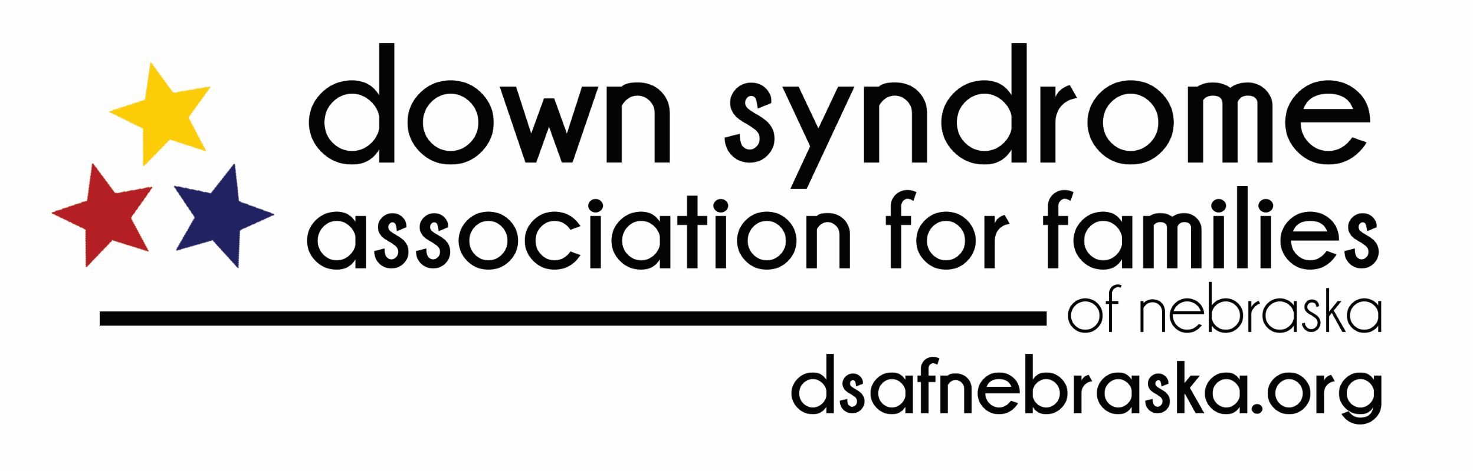

Job Title: Part Time Program Director

Reports to: Executive Committee / Board of Directors

Are you a person who thrives on building and growing relationships? Does the idea of helping families who have a loved one with Down syndrome excite you? Do you possess the skillset to manage multiple projects at the same time and the detail-orientation to execute them to their highest potential? Does it energize you to think of working independently to meet deadlines while providing exceptional service to DSAF members?

Down Syndrome Association for Families of Nebraska (DSAF) is seeking a Program Director to play a key role in the management, growth, and operations for the organization’s current and new initiatives, programs, and events. Candidates must possess an ability to communicate clearly and be a highly motivated individual who excels at the entire spectrum of program and project management. This position allows the benefit of a flexible work schedule in a virtual office setting. Weekend and evening hours are dependent on demands and the event schedule. DSAF will support and encourage continued education regarding the topic of Down syndrome.

Duties and Responsibilities:

Education, Events and Programming:
- Oversee the event planning and coordination in a cost-effective manner of the 5 main annual events, the annual multi-track educational conference, and other existing programs
- Assist volunteer committees, where needed, with existing and new DSAF events
- Assist with the annual Step Up for Down Syndrome Walk planning and day-of activities and attend monthly Step Up for Down Syndrome Walk planning meetings
- Implement new programs as defined by the Board
- Represent DSAF in public by attending the 5 main annual events, the annual multi-track educational conference, and other existing programs where the board requests attendance, not to exceed 2-3 evening and/or weekend events per month

Public Awareness:
- Collaborate with Marketing and Development Director to enhance public awareness of DSAF’s presence, mission, and activities via web and social media
- Collaborate with Marketing and Development Director on production of the Annual Report

Administration:
- Create and maintain files, operating policies, procedures, and forms as requested by the board
- Attendance at Board, Executive Committee meetings, and occasional other committee meetings
- Provide customer service to existing DSAF membership
- Coordinate with Marketing and Development Director on volunteer and membership tracking and database management

Organizational Development / Training:
- Organize committee chair brunches and continued communications
- Coordinate and participate in the board annual strategic planning session
- Option to attend the annual Affiliates in Action national conference
- Manage the DSAF Living Strategic Project Plan

Qualifications:

Minimum:  - Excellent written and verbal communication skills  - Positive work relationships  - Knowledge and skill with a variety of software programs, including Microsoft computer applications (Word, Excel, PowerPoint, etc.)  - History of working productively and independently  - Experience with event planning  - College degree or relevant experience  - Experience with Project Management  - Excellent organization skills | Preferred:  - Experience with the following:  - Social media  - Report writing  - Database creation and management  - Non-profit organizations  - Strategic planning

DSAF is a vibrant non-profit (501c3) organization with a mission to provide support for individuals with Down syndrome, their families, friends, educators, and professionals who share in their lives. Every person with Down syndrome is an individual who has a unique purpose and set of abilities. If you are interested in being a part of a team that provides a network and positive vision for the future for individuals with Down syndrome, please submit a cover letter and resume to dsafemployment@gmail.com.

